Y2Q1W4

Absalom
Ask: Do other people ever upset you?
Ask: What do you do when they upset you?
Ask: Are you ever upset by something your parents do?
Ask: What did you do about it?
Say: Today we are going to learn what happened to King David's family when one of his sons was upset with his brother and father.

Bible Story with Delwyn
Say: That's a very different ending from our last few weeks isn't it? Revise the last couple of lessons.
Sing some songs.

Say: Today we are going to make up a story.
Story: Choose a name for the child and then say child thinks he is never chosen by the teacher even though s/he tries to get their attention. Another child seems to be always chosen.
Ask: How does the first child feel?
Ask: What might they be able to do about it?
Say: We are going to return to our tables and do our Bible verses and discuss more possible endings to our story.

Return to tables
Memory Verse: Fill in the blanks and then say the memory verse on the colouring page.
Say: Every week this term we will be making a page to add to a scrapbook.
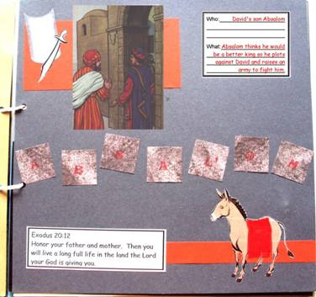
Craft:
- Choose a coloured cardboard
- Cut Absalom's name into letters and stick on.
- Stick on photo, sword & shield, donkey, verse and who/what card.
- Cut a saddle from cloth and glue on the donkey.

Discuss the following depending on age, interest and time:
How did each person in the Bible story feel? (Absalom – angry, revengeful, jealous; David – sad, angry, upset)
What things happen that upset you? How does it make you feel?
What could the child in our story do? What could be the results?
What can you do when you think things are unfair?
Who should be in charge of discipline? (Parents / Teachers)
How do you feel when your brother or sister tells you, you are doing the wrong thing?
What if things never seem to become fair? - Read Romans 12:19 (Vengeance is God's)

Primary / Junior / Teen: This term, those of you who would like to get a Bible to take home, may take one of the orange Commandment pages and add to your book. Each week you come you can put a sticker on it and when it is all complete we will get you a Bible to take home and keep.

Ask: Do you know what happens when you are upset and you keep it inside and never talk about it? Say: It grows inside you and becomes anger and hate.
Ask: Can you be happy when you have anger and hate inside you?
Say: Does telling everyone about it or yelling or throwing things or hurting people fix the problem?
Say: There are three people it is good to talk to. The first and most important is God. He will help you to feel better, maybe to understand or to know what to do.
Say: The 2nd is the person who has upset you. Maybe they didn't even know you were upset.
Say: The 3rd person is an adult that you trust.
Ask: What should you do if things still seem unfair?
Say: Romans 12:19 says "Dear friends, never take revenge. Leave that to the righteous anger of God. For the Scriptures say, “I will take revenge; I will pay them back", says the Lord.
Say: Even if things don't seem fair, we should not take revenge. God say's that He will do that. It might not be straight away, but in the end we can trust that God will do what is fair.
Finish with prayer at each table.

